Setting Up Application Environment

Install IBM Cloud CLI

|  |  |
| --- | --- |
| Date | 11 November 2022 |
| Team ID | PNT2022TMID42604 |
| Project Name | SMART FASHION RECOMMENDER APPLICATION |
| Team Members | Sangamitra S  Sathish M  Tharini Mala S K  Venkat Raman P |

**Installation of IBM Cloud CLI:**

**Step 1:**

Login to your IBM Cloud [*https://cloud.ibm.com*](https://cloud.ibm.com)and in-search bar you can type **Container registry** and click to get started as shown in image.

**1.1 login.**

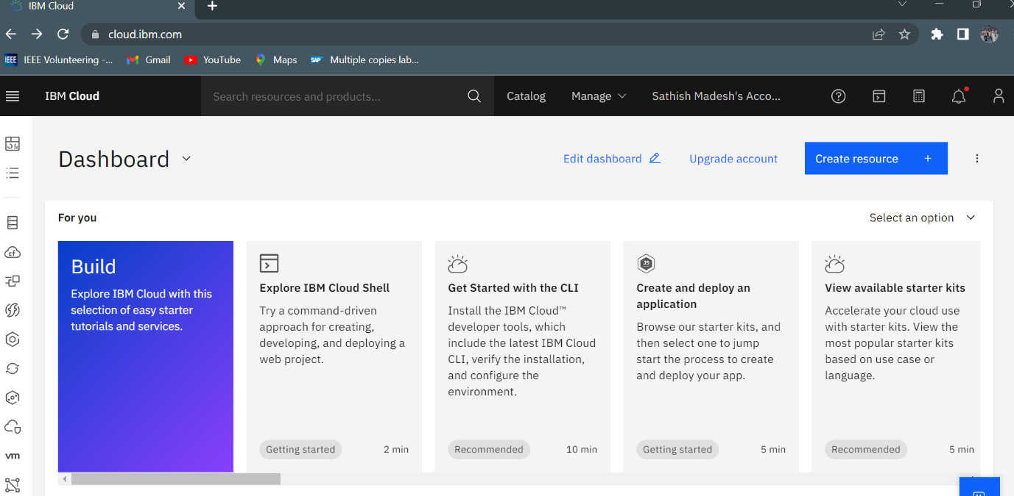

**1.2 Search Container Registry**

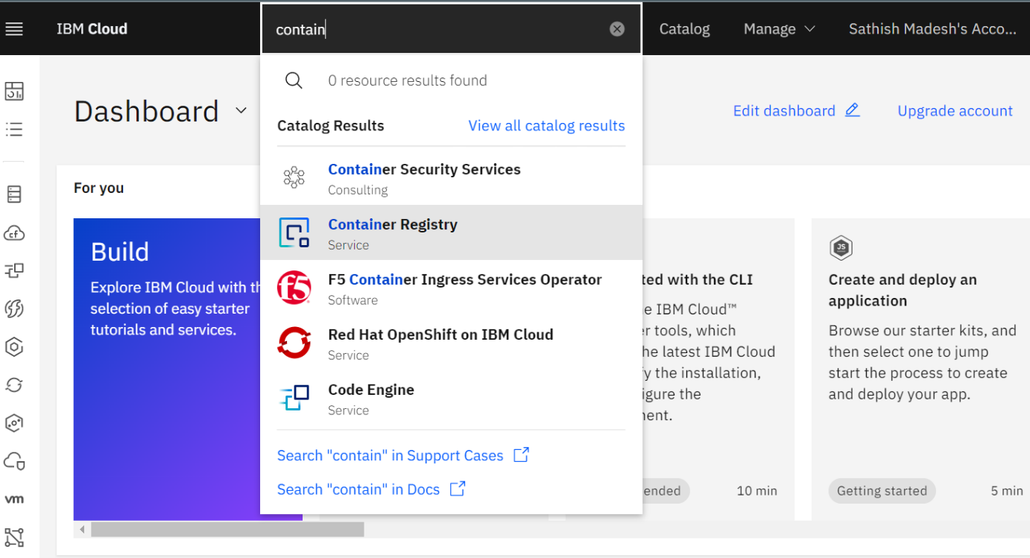

**1.3 Select Get started**

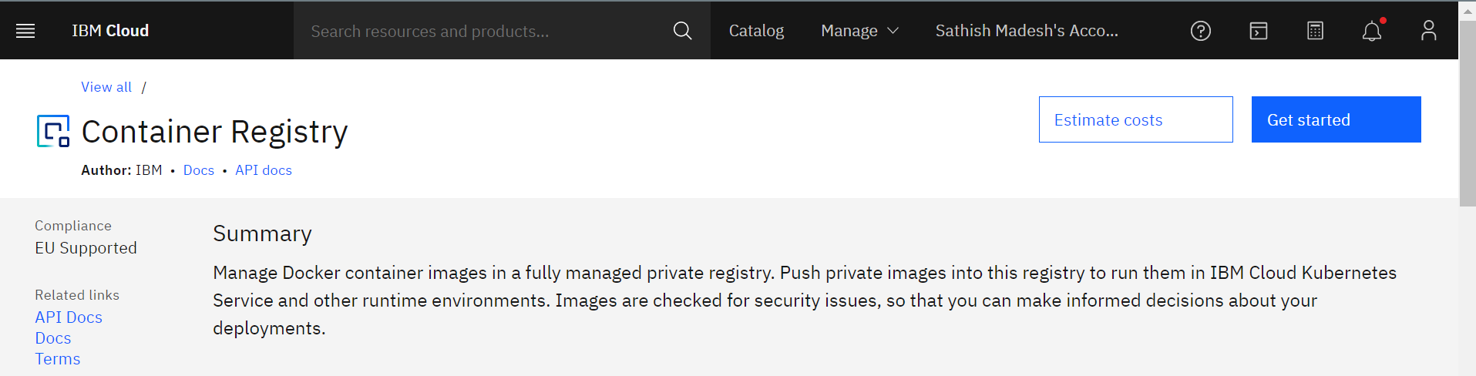

**Step 2:**

Follow the steps given in the page one by one to install IBM Cloud CLI

[*https://cloud.ibm.com/registry/start*](https://cloud.ibm.com/registry/start)

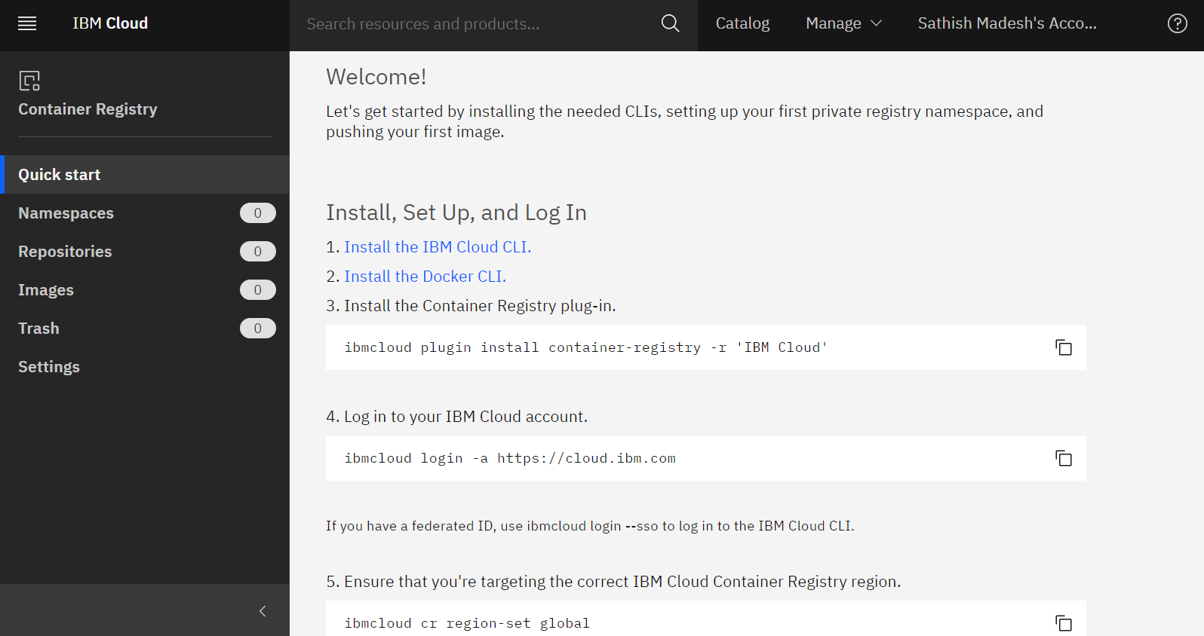

**Step 3:**

Follow the steps in the installation of cloud cli given,

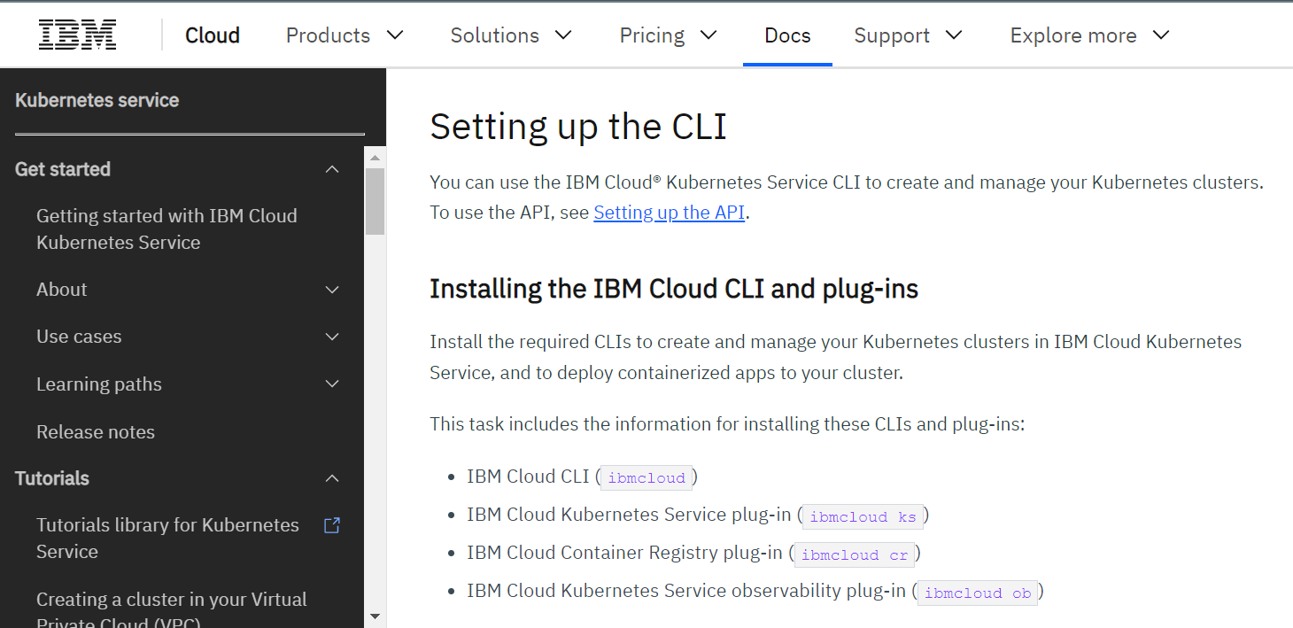

**Step 4:**

Run the installer.

Give following steps in cmd.

1. ibmcloud login
2. ibmcloud plugin install container-service
3. ibmcloud plugin install container-registry
4. ibmcloud plugin install observe-service
5. ibmcloud plugin list

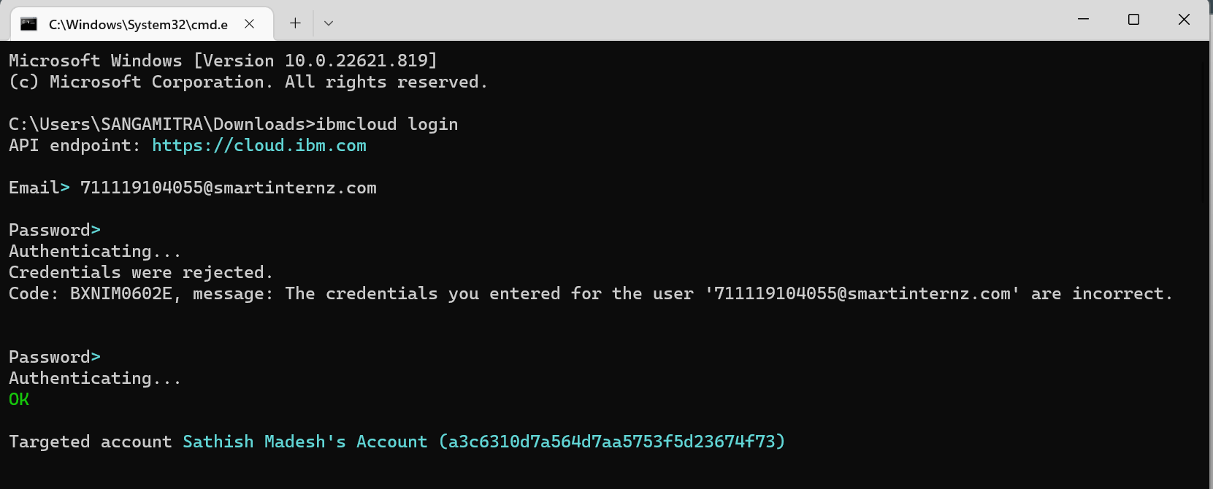

Successfully Installed and run.